SN | Task | Remark
1 | User’s registered under Different Business should be directed through – URL Paysecure247.com (at present it is done at url fairplayofficial.com | ??
2 | Give all websites different designs with own home page content. So that it would’t appear that all the 3 domains are run under same project. That’s why we have taken different domain names for each segment. | ??
3 | In investor panel when an Investor logs in ask him to use a plan 25k/50k/1 lac/ 2 lac – after selction of plan show him Withdrawal request of equivalent to 110% of plan amount he has choosen. > Now he can start making payments (investments). He can choose one any of the available payments to complete his target one by one (choosen payment will not be visible to other investor for next 7 minutes (keep this dynamic controllable by admin panel). This is done to to give time to investor to complete his payment. After completion of stipulated time the locked payment will be available to other users/Investors.
4 | How admin will be identify that a particular user is registered under which business?? At present this is not visible to me in admin panel and user panel. | Resolved
5 | I have just registered a user under business name “Mahavir” by the name Raju dummy as user but it is not visible under that business to me. | Resolved
6 | I have made a widrawal request from rajudummy request reached successfully to “Mahavir” business and business is able to approve it as well. But problem is how business will identify that he is his user or not ?? Allow business to set or allocate some code for his users so that business can easily identify. | Resolved
7 | Remove this word P2P from everywhere on platform. Please replace it by Platform Payment. | Resolved
8 | Don’t allow user to cancel withdrawal request submitted by him. A request needs to cancelled by Concerned business or admin only. Give user a time tat of 2 minutes with timer (dynamic which will be set by admin) so that user can cancel/edit it within that time frame only. Once the time TAT is over only then send his this request to business for approval and once the request is approved by business then user cannot cancel the widrawal request don’t show user cancel button after TAT is over. Apply this for investors withdrawal requests also. And give a note to user/investor that once request is approved it cannot be edited/deleted. | This bold text is to be resolved some part is corrected some part is pending
9 | When a investor accepts any withdrawal for making payment show him stop watch clearly stating that if any payment is submitted after time over it will not be Valid/Accepted. ( show him timer of 5 minutes to submit the request but in backend don’t show the particular payment (widrawal) to any one for atleast 7 minutes.
10 | Whenever user/investor gives his upi id please system to convert it to scanner/QR code as well.
11 | Ticket raised by user is visible to admin but it is not showing to concerned business please check.
12 | Investor has paid full amount (Rs 10,000)of withdrawal request of a business user but in notification to user to says partial payment received- but this is complete payment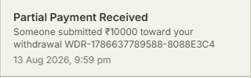
13 | 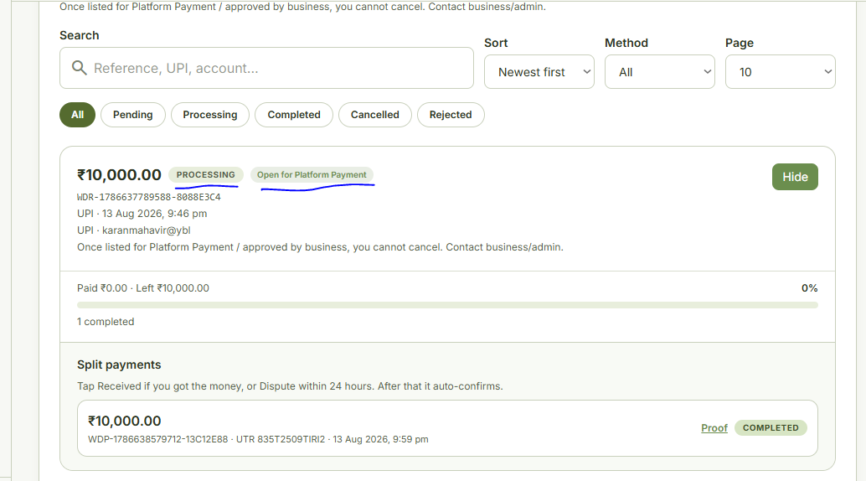  In above SS payment received is confirmed by User himself, then why it showing under Processing, Open for Platform Payment. It should Be now in Completed Status I think.
14 | When a Investors raise a request for Withdrawal he is getting option to enter additional notes in UPI/BANK/USDT…remove this note box in all three modes. It may be used by investor to send any other unwanted information.
15 | In User/Investor withdrwal forms Customise the fileds Like  Name Field should allow to enter Alphabets and Space and no numeric should be allowed,  UPI id filed should not allow more than 9 consecutive numeric characters in it,  Account Number filed should allow only numeric characters,  IFSC code filed should allow both alpha numeric characters it has total 11 characters first 4 characters are alphabets 5th character is Numeric “zero”next 6 charaters are alpa numeric  Bank Name should be Complusory at present it is optional
16 | When a User/Investor enters details for withdrawal show these detail once again before final submission so that he can verify the details. After submission also show him these details so that he can decide if he has to cancel the request ( NAME,IFSC CODE, ACCOUNTNo, BANK name)
17 | User withdrwal details like NAME,IFSC CODE, ACCOUNT No, BANK name or UPI id should be clearly visible to Business as well to decide whether to approve the request for reject it.
18 | Can we implant any api etc to verify Bank details in system which can verify through Account Number name of Account holder??
19 | Withdrawal is visible to Admin but withdrawal details are not visible to Admin …then how would Admin will be able to take any action. Show details to admin as well.
20 | When a investor makes any payment as investment, it is hot showing in Admin panel..why it is so?? How will admin monitor the system , admin should have access to all the data and entries
21 | You received ₹5,340.00. “This unlocks the payer investment” and cannot be undone easily. Why these details are shown to user once he confirms that he has received the payment.
22 | 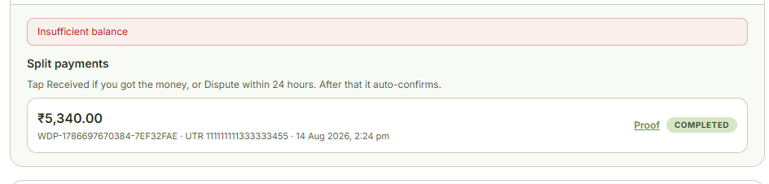  What is this insufficient balance warning to user once he received the payment
23 | User 1 of Business has made a withdrwal request, this request is not available to user 2 of Same Business for Deposit. | TEST THIS AGAIN
24 | Any withdrwal request by user remains visibile to him only till 2 minute (dynamic) time TAT. Once this TAT is over then it will be visible to his Business and once approved by Business then it sould be visible to Admin panel as well and all other concerned parties for making deposit to his withdrawal request. At present it is visible to Business , Admin & Investors during this 2 minute time TAT.
25 | Withdrawal request raised by user of business 1 and paid by user of business 2. This transactions is not appearing in appearing in user login of business 2 till the time user of business 1 accepted it. Why it is so…he should have knowldege about the status of deposit has made from very beginning. Further to note that business 2 also doesn’t have any knowledge about this transaction neither before acceptance nor after acceptance
26 | In Complete Model commission is charged from Business for there user’s deposit/witdrawal by admin panel . We don’t have to charge or Commision on widrawal or deposit from users. At present I am able to see Commision entries in ledger of users of business. (Rate of commision to be charged from business is controlled by admin panel and keep the rates dynamic so that these can be adjusted at any point of time in future)  Admin Panel will Give Commision to Investor on Deposits and widrawals only after sucessful completion of there target plan we will added up the commission in there wallet which can be widrawn by investor only after Successful completion of target amount/plan. (Rate of commision to be given to investor is controlled by admin panel and keep the rates dynamic so that these can be adjusted at any point of time in future)
27

